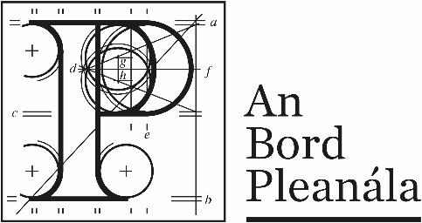
Documents received at Oral Hearing for
ABP-314232-22

Case Description | DART+ West Railway Order - Dublin City to Maynooth and M3 Parkway County Dublin, County Meath, County Kildare
Date | 3rd October, 2023
Location | 64 Marlborough Street, Dublin 1, D01 V902

Documents received at Oral Hearing
No. | Submitted by | Presenter | Topic
 | Denis Baker - Inland Waterways Association of Ireland - Royal Canal Branch | John Danam | Module B - submission
 | Dr. Kevin Reid | Dr. Kevin Reid | Module C  Ashtown Stables submission
 | Christopher Reid | Christopher Reid | Module C  Ashtown Stables submission
 | Grainne Reid | Grainne Reid | Module C  Ashtown Stables
 | Colette Maguire & David Conroy | Colette Maguire | Module B  1.Submission  2.Supplementary Information Number 1  3. Supplementary Information Number 2  4. Supplementary Information Number 3
 | Anna Lalor | Anna Lalor | Module C Rathbourne Village Residents Association - Slides

